**Renewal Based Model**

* The renewal model gives us two ways you define how salesforce CPQ track the products we quote and sell to our Account.
* Set renewal model in subscription and Renewals package settings.

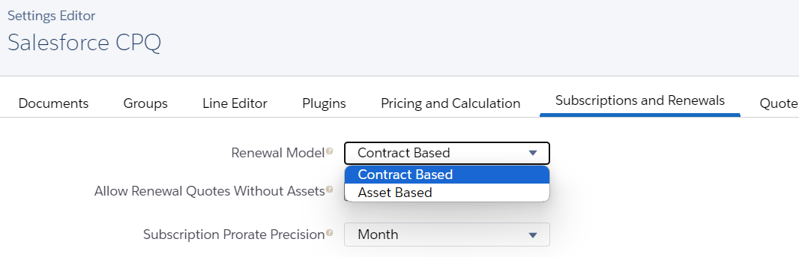

**Contract Based Renewal Model –**

**Contract -**

* Contract records show us the subscription based products that we sold to customers
* It by default does not store the legal binding/ between two parties.
* Generate a lasting record of products and services a customer has purchased or subscribed to.
* Once the deal is sealed, and opportunity is Closed-Won, we can use the "Contracted" checkbox on Opportunity to initiate Contracting Process.
* Initiation can be done from Opportunity or Orders (If the order functionality is used)
* Use Subscription to keep records of Subscription products we have quoted or sold.
* Use Assets to keep records of standalone products we have quoted or sold.
* Use these records later to manage amendments and renewal to our opportunities and orders.
* When we contract an opportunity or order with at least one subscription product under a contract-based renewal model, Salesforce CPQ creates a contract record.
* It then creates subscription records for the Quotes' subscription products and asset records for the quote's products with asset conversion.
* Asset Conversion field at Product -

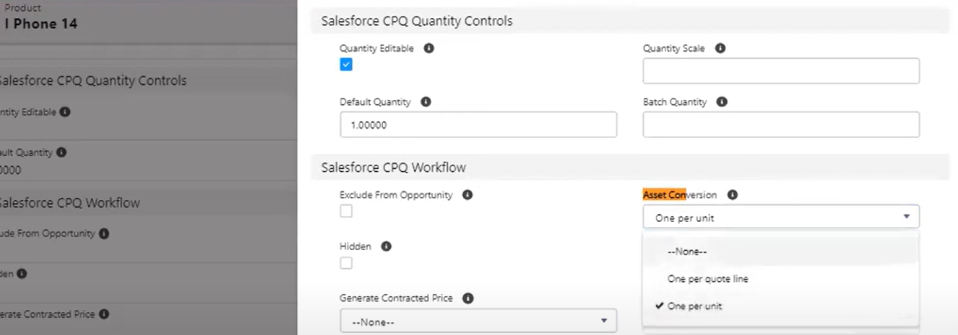

* Use the contract record to track the following information for subscriptions. (Quantity, Start date, End date, Renewal, and amendment settings)
* Contracting an opportunity or order should locks the original quote lines from further changes.
  1. To change those quote Lines, Sales reps must amend the contact and edit the quote lines on the amendment quote.
  2. If the contract is ready for renewal, they can also renew the contract and change the quote line on renewal quote.

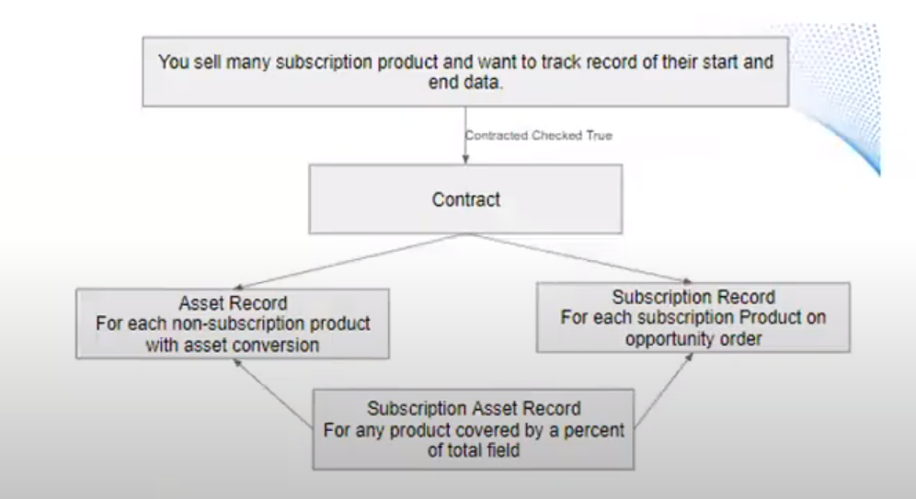

**Asset Base Renewal Model** –

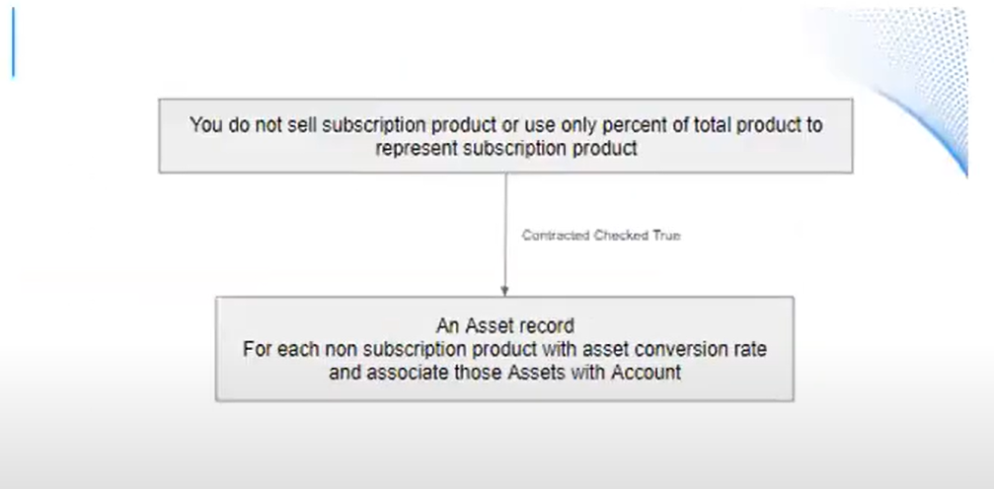

**Contract From Opportunity-**

* Salesforce CPQ Requires the following objects and settings when we create a contract from an opportunity.
* An opportunity with at least one subscription product
* A primary quote that looks up to your opportunity
* A contract based renewal model on your opportunity's account
* To contract opportunity select Contracted on the opportunity record - The Contract is created in background
* Salesforce CPC then created a subscription record for each of the subscription products.
* These records contain pricing and date values for each subscription products quoted.
* Access the subscription record from your contracts subscription related list.
* By default, the subscription inherits its start and end dates from the quote line group's start and end dates
* If the quote line groups dates are null, the subscription inherits its start and end dates from the quote line's start and end
* If the quote line's dates are null, the subscription record inherits its start and end dates from the quote line's start and end date value.
* Subscription inherit the values of all other matching quote line fields
* Salesforce CPQ creates assets for the perpetual products that have 'one per unit' or 'one per quote line' asset conversion.
* These records contain pricing values for the non-subscription product you quoted
* Assets can be accessed from Account.

**Renewal Process (Contract – Based)**

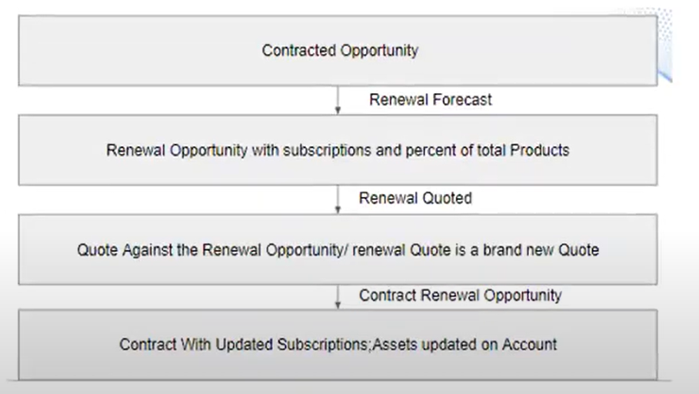

**Renewal Process (Asset – Based)**

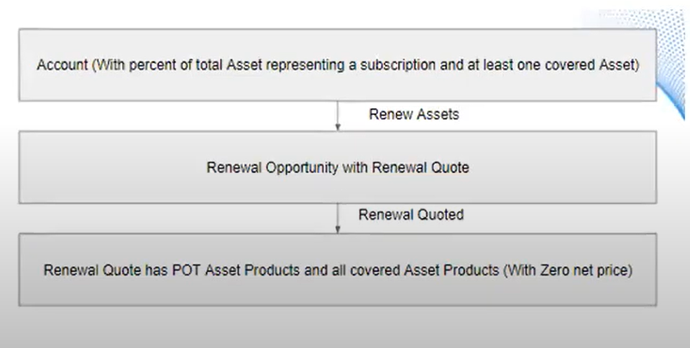

Interview Questions-

1. Customer wants if in QLE user added 2 quantities of a product then system should create 2 Assets, Can we do that?
2. How can we stop sales reps to do any changes in an contracted quote?
3. How you can start the renewal process?  
   Or  
   What are various type of renewals in salesforce CPQ?
4. In ***Contract based renewal***, sales reps want to contract a quote where we have Subscription, Non-subscription, and a Percent of total (PoT) product. After contracting, can you please tell which product will get tagged to Assets and Subscriptions?
5. In ***Asset based renewal***, sales reps want to contract a quote where we have Subscription, Non-subscription, and a Percent of total (PoT) product. After contracting, can you please tell which product will get tagged to Assets and Subscriptions?